**What Is Reinforcement Learning**

At its core, reinforcement learning is a type of machine learning where an agent learns to make decisions by taking actions in an environment. The agent's goal is to maximize a cumulative reward over time. Think of it as a digital playground where the agent explores, experiments, and adapts to optimize its performance continually.

Here's the basic framework:

**Agent**: This is our learner, the entity making decisions and taking actions.

**Environment**: The agent interacts with this external system, which provides feedback and consequences to the agent's actions.

**Actions**: These are the choices made by the agent to affect the environment.

**Rewards**: Feedback from the environment, typically in the form of positive or negative values, indicating the desirability of the agent's actions.

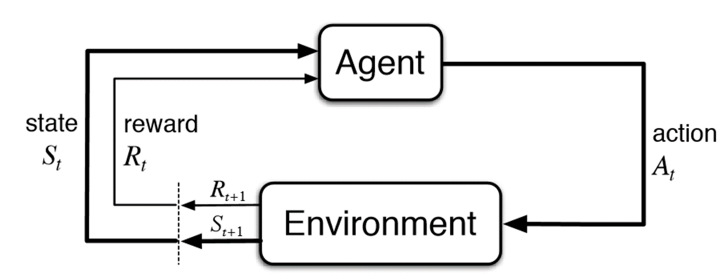

**How Does Reinforcement Learning Work?**

Reinforcement learning follows a simple yet powerful paradigm:

* **Exploration**: The agent starts by exploring its environment, taking random actions or educated guesses to understand the consequences.
* **Exploitation**: As the agent learns, it begins to exploit its knowledge to make better decisions and receive higher rewards.

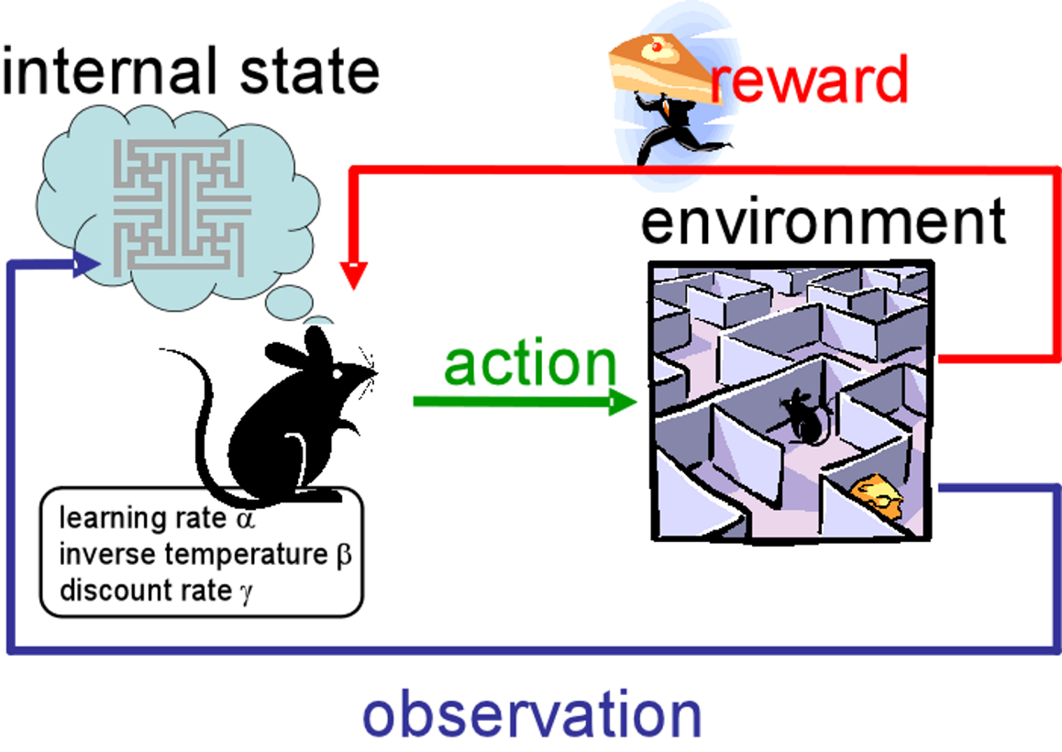

* **Learning**: The agent learns from its past experiences, adjusting its strategy based on the rewards it receives.
* **Policy**: Over time, the agent develops a policy—a strategy for selecting actions that maximize its expected reward.

**Applications of Reinforcement Learning**

Reinforcement learning has found applications in a wide range of domains:

→ **Gaming**: RL-powered agents have conquered complex games like chess and Go, showcasing the potential of RL in decision-making tasks.

→ **Robotics**: RL enables robots to learn tasks like walking, picking and placing objects, and even surgical procedures.

→ **Autonomous Vehicles**: Self-driving cars use RL to navigate and make decisions on the road.

→ **Recommendation Systems**: Online platforms use RL algorithms to suggest content, products, or ads to users.

→ **Healthcare**: RL is applied in personalized treatment planning and optimizing healthcare resource allocation.

→ **Finance**: It's used for portfolio optimization, algorithmic trading, and fraud detection.

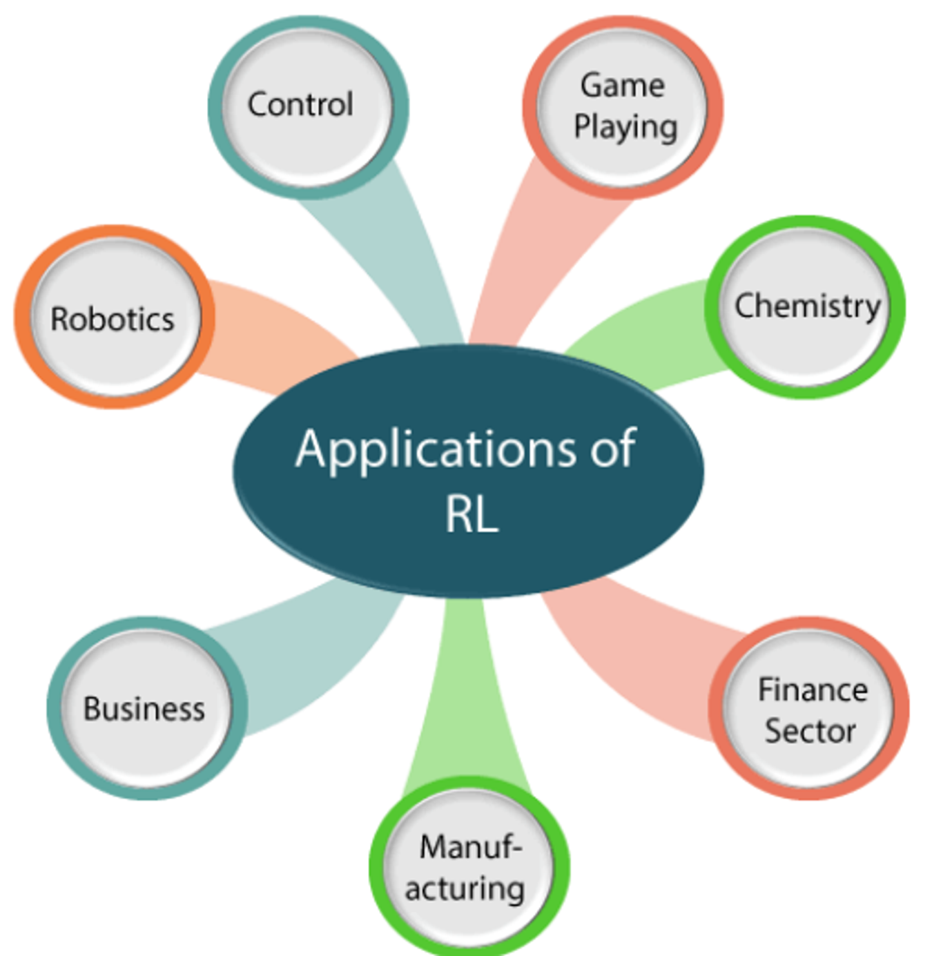

**Conclusion**

Reinforcement learning is a powerful concept that bridges the gap between artificial intelligence and human-like decision-making.

By allowing machines to learn from their interactions with the environment, RL has the potential to revolutionize numerous industries. It enables computers to adapt, evolve, and make decisions in complex, dynamic scenarios, much like we do as humans.

Embracing RL not only opens up exciting possibilities for technology but also challenges us to think differently about how machines can learn and adapt.